BAHRIA UNIVERSITY KARACHI CAMPUS
Department of Computer Science

APPLIED PHYSICS

LAB EXPERIMENT # 6

Voltage divider circuit

OBJECTIVE:-
- Designing of voltage divider circuit to obtain desired values of voltage.

EQUIPMENT:-

- Multimeter.
- 5 kΩ constant resistance.
- A constant DC voltage source (10 V).

THEORY:-

"Voltage divider circuit is a series combination of resistances
Which can be used to obtain desired values of voltages at its
Intermediate nodes".

If resistors are combined to form a series circuit and a voltage is applied across its end terminals that voltage is divided across each resistor in proportion to its resistance value.
Using Fig-1 we can show that:
R1
V₁
V_{S} =10V
Rx
V_{x}
Fig-1

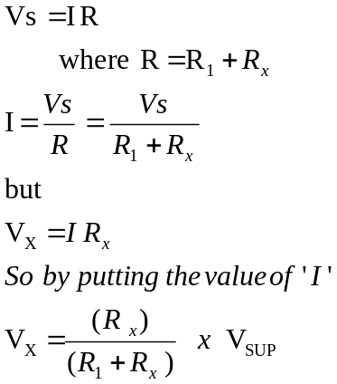
PROCEDURE:-

- Fabricate the circuit given in Fig-1 on the Vero board.
- Apply a constant DC voltage of 10 Volt input terminals.
- Set the value of R_{x} as indicated in the Table-1 and measure the voltages V₁ and Vx by using voltmeter.
- Calculate the value of Vx for all values of Rx by using Eq-1.
- Find the % Error between calculated and measured values.

OBSERVATIONS:-

R₁ = 5 kΩ

S.N | R_{x} | Measured Values |  | Calculated Values |  | % Error =  Calc Vx - Meas Vx X 100  Calc Vx
S.N | R_{x} | V₁ | Vx | V₁ | Vx | % Error =  Calc Vx - Meas Vx X 100  Calc Vx
1 | 10 Ω | 9.98V | 19.96mV | 9.98V | 19.99mv | 0.1500
2 | 100 Ω | 9.804 | 196.079mV
3 | 1 kΩ | 8.33V | 1.667V
4 | 5 kΩ | 5v | 5v
5 | 10 kΩ | 3.33V | 6.667V | 3.33V | 6.667V
6 | 100 kΩ | 9.52v | 476.234mv

CALCULATIONS:-

Put each set of values of R₁, R_{x} and V_{SUP} in the equation below and perform calculations.
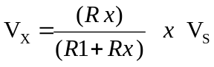 --------- Eq-1

COMMENTS:-

Comment for the comparison of measured and calculated values of Vx:

Teacher Signature: ________________________

Student Registration No: ________________________

